**Task 02**

**Name: Abdullah Butt Roll Number: 018**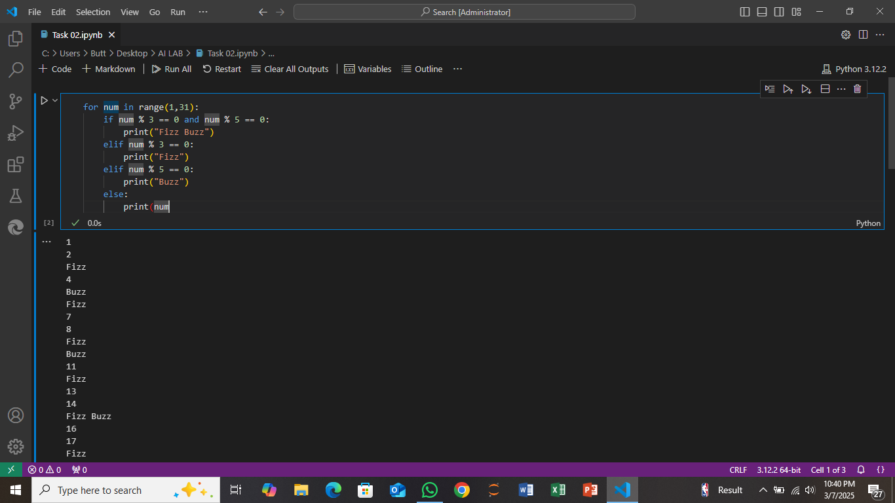

**Explanation:**

This code is a simple implementation of the classic "Fizz Buzz" problem. The code loops through numbers from 1 to 30. For each number, it checks if the number is divisible by both 3 and 5, by 3 only, or by 5 only.

* If the number is divisible by both 3 and 5 (meaning the number is a multiple of both), it prints "Fizz Buzz".
* If the number is only divisible by 3 (a multiple of 3 but not 5), it prints "Fizz".
* If the number is only divisible by 5 (a multiple of 5 but not 3), it prints "Buzz".
* If the number is not divisible by either 3 or 5, it just prints the number itself.

The purpose of this code is to print the correct word (Fizz, Buzz, or Fizz Buzz) for numbers based on their divisibility, and if neither condition applies, it simply prints the number.

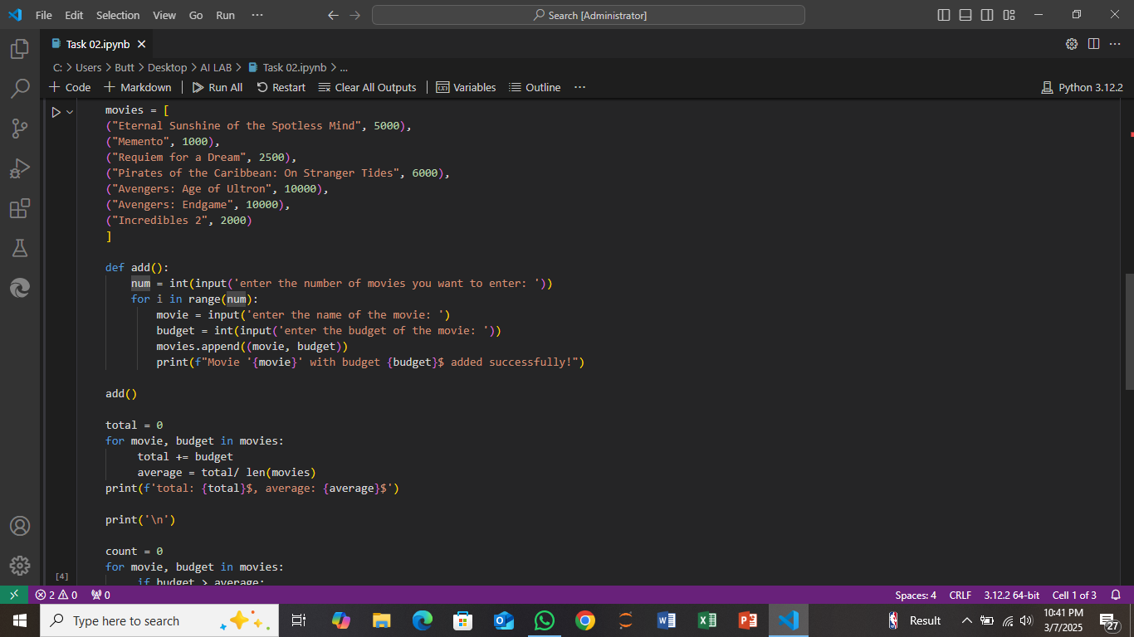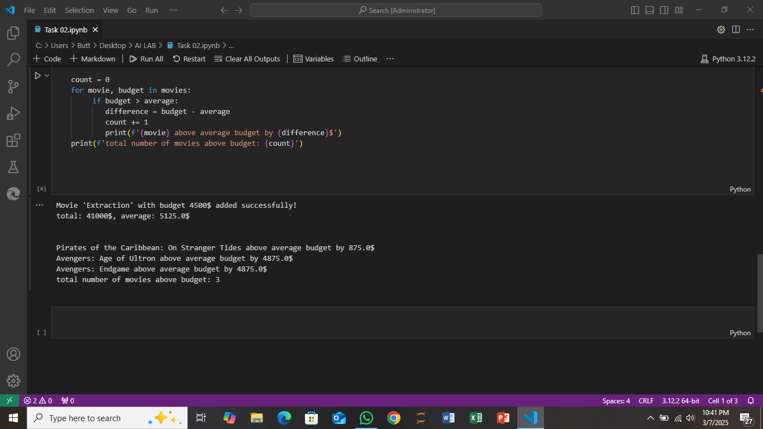

**Explanation:**

This code works with a list of movies and their budgets. It allows the user to add more movies and their budgets, then calculates the total budget for all the movies and the average budget. Here's a breakdown of how it works:

1. **Movies List**: The code starts with a list of movies, each stored as a tuple containing the movie's name and its budget (in dollars). For example, the movie "Eternal Sunshine of the Spotless Mind" has a budget of 5000 dollars.
2. **Adding Movies**: The add() function asks the user how many movies they want to enter. Then, it asks for the name and budget of each movie. The new movie information is added to the movies list, and the function prints a confirmation message for each movie added.
3. **Calculating Total and Average Budget**: After adding movies, the code calculates the total budget for all movies in the list by looping through each movie and adding its budget to a running total. Then, it divides this total by the number of movies to find the average budget.
4. **Movies Above Average Budget**: The code then checks each movie to see if its budget is above the average budget. If a movie's budget is higher than average, it calculates the difference and prints how much higher the budget is compared to the average. It also keeps a count of how many movies are above the average budget.
5. **Results**: Finally, it prints the total budget for all movies, the average budget, and details about the movies whose budgets are above the average, including how much above average they are.

In simpler terms, this code allows the user to add new movies, calculate the total and average budgets, and find which movies have a higher budget than the average.